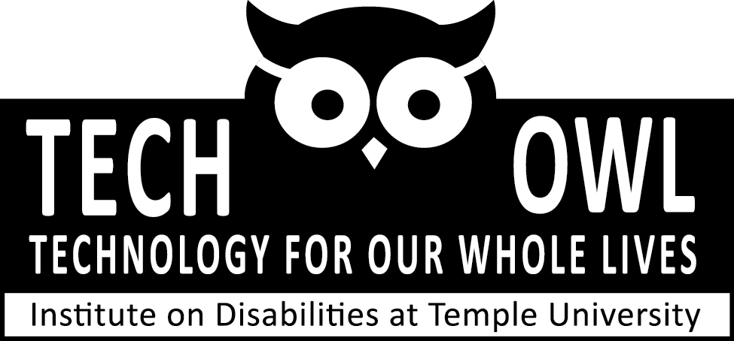
www.techowlpa.org
Tools and services to help people
-A.T. Lending Library -Demonstrations
-Free Special Phones -Funding Options
-Reuse Program -Problem Solving

ASSISTIVE TECHNOLOGY PROGRAMS IN PENNSYLVANIA

PA’s Assistive Technology Lending Library (PA’s ATLL)
PA’s ATLL is a free program for Pennsylvanians with disabilities.
-Any age, any disability. -Delivered and picked up by UPS.
-Short- term trial of assistive technology devices; 2-4 weeks.
-“Try before you buy”. -Hundreds of devices to borrow.

Telecommunication Device Distribution Program (TDDP)
Provides free adaptive phones for those who qualify.
-PA resident with a qualifying disability.- Ages 6 years and up.
-Have access to a landline phone. -Meets income guidelines

Reused and Exchange Equipment Partnership (REEP)
REEP is a free online classifieds for assistive technology devices.
Items listed can be for sale or for free. Free to buy, sell, or browse.
The ATRC operates a free in-house reuse program for gently used Assistive Technology equipment. Call to donate or receive items.

Pennsylvania Assistive Technology Financing Program
The Pennsylvania Assistive Technology Foundation (PATF), an independent, not-for-profit corporation. PATF has created 2 loan programs for to assist Pennsylvanians with disabilities to purchase the Assistive Technology they need.
100.00-2,000.00= 0% interest; 2,000.00-35,000.00= low interest.
http://patf.us/
iCanConnect
The National Deaf-Blind Equipment Distribution Program (NDBEDP), will ensure that low-income individuals who have combined hearing and vision loss can access telephone, advanced communications and information services.

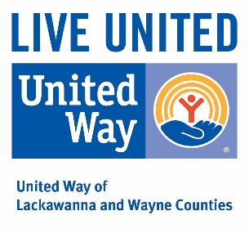
For more information contact the Assistive Technology Resource Center at UCP Supported by:
55 Utley Drive
Camp Hill, PA 17011
(Voice) 1-877-UCP-TECH
(FAX) 717-737-9017
(TTY) 717-737-3477
(email) ATUCP@ucpcentralpa.org
United
Cerebral
Palsy

